Anatomy of Your Google Calendar (Default View: Week)
2
3
1
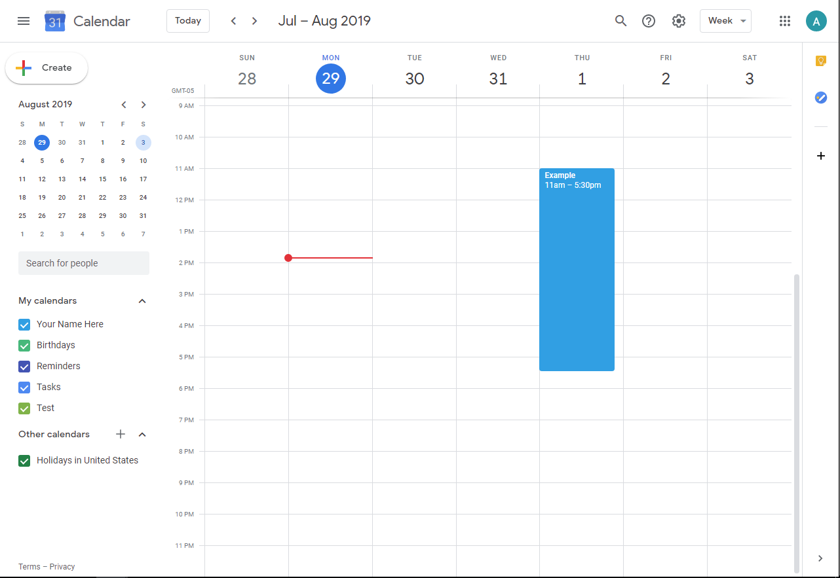
6
8
7
4
5

What’s am I looking at?

- Click here to see your account and log out.
- Change your view to see your calendar in month, day, year, schedule, or 4-day.
- Calendar settings.
- The date/time right now.
- Create a new event (you can also do this by clicking on the date and time you would like the event to be, on the calendar itself).
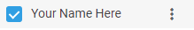
- Your calendars—uncheck them to remove them from the overall calendar view and only see certain events. Edit a calendar by hovering over its name in this list and clicking the three vertical dots that appear to the right:
- Click the plus sign (+) to add a calendar.
- How events display on your calendar. Click the block to edit the event.

Creating a New Event
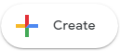
- Click the button or the date and time you wish the event to take place.
- A panel should come up like this:
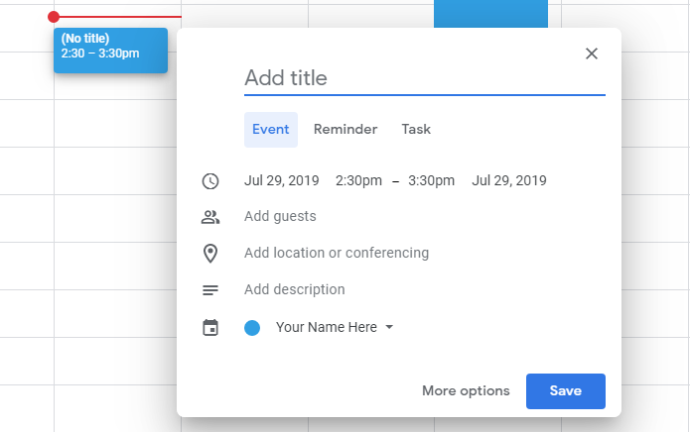
- It will default to the Event setting, but click Reminder or Task to get different fields.
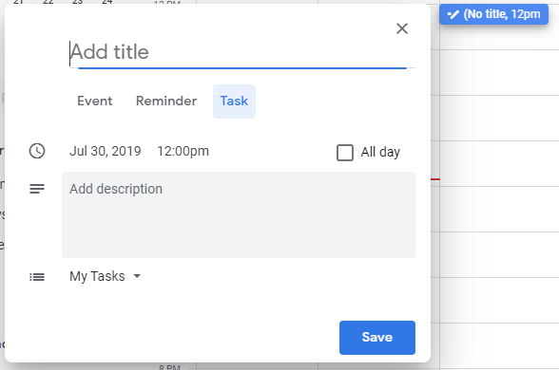
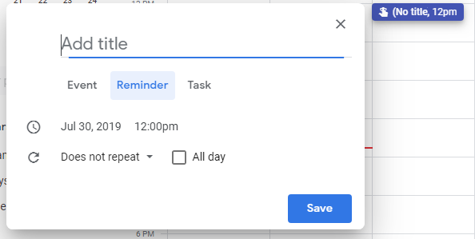

- Click anything you want to change. For instance, if you need your event to be longer, click the end time—in this case, 3:30—and make it whatever you need it to be. 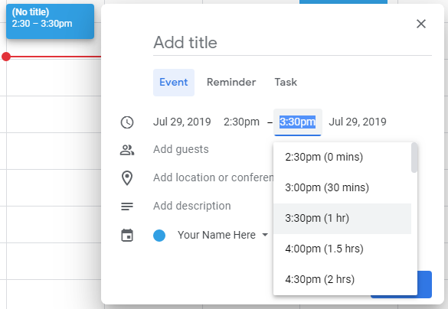
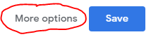
- If you need more tools—for instance, if you want to make a repeating event or change your notifications, click the more options button at the bottom.
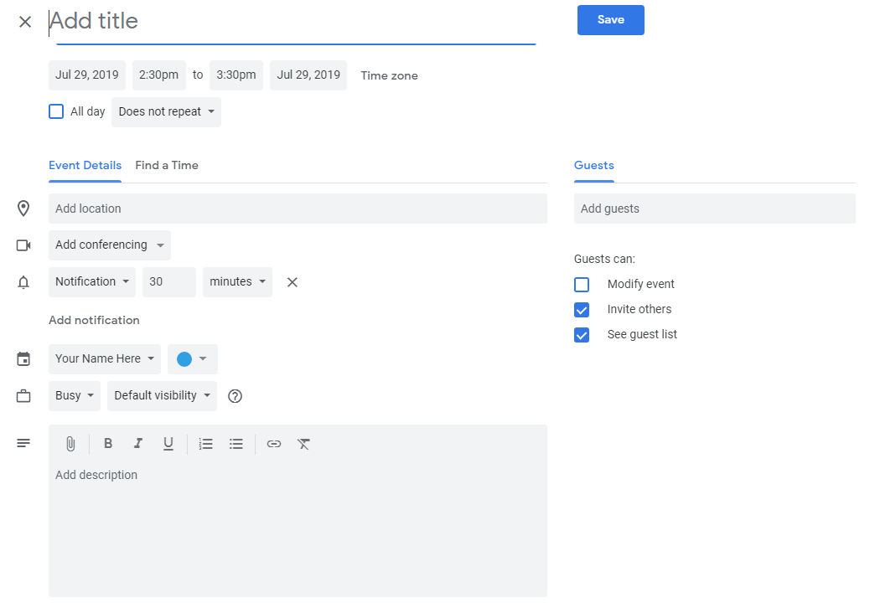
- This will take you here:

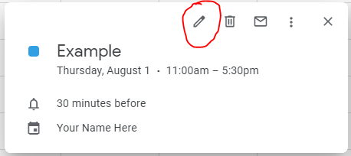
- If you need to edit your event again after you’re created it, the edit button is here, and that will take you to the page in step 6 again.

