The Anatomy of a YouTube Video
8

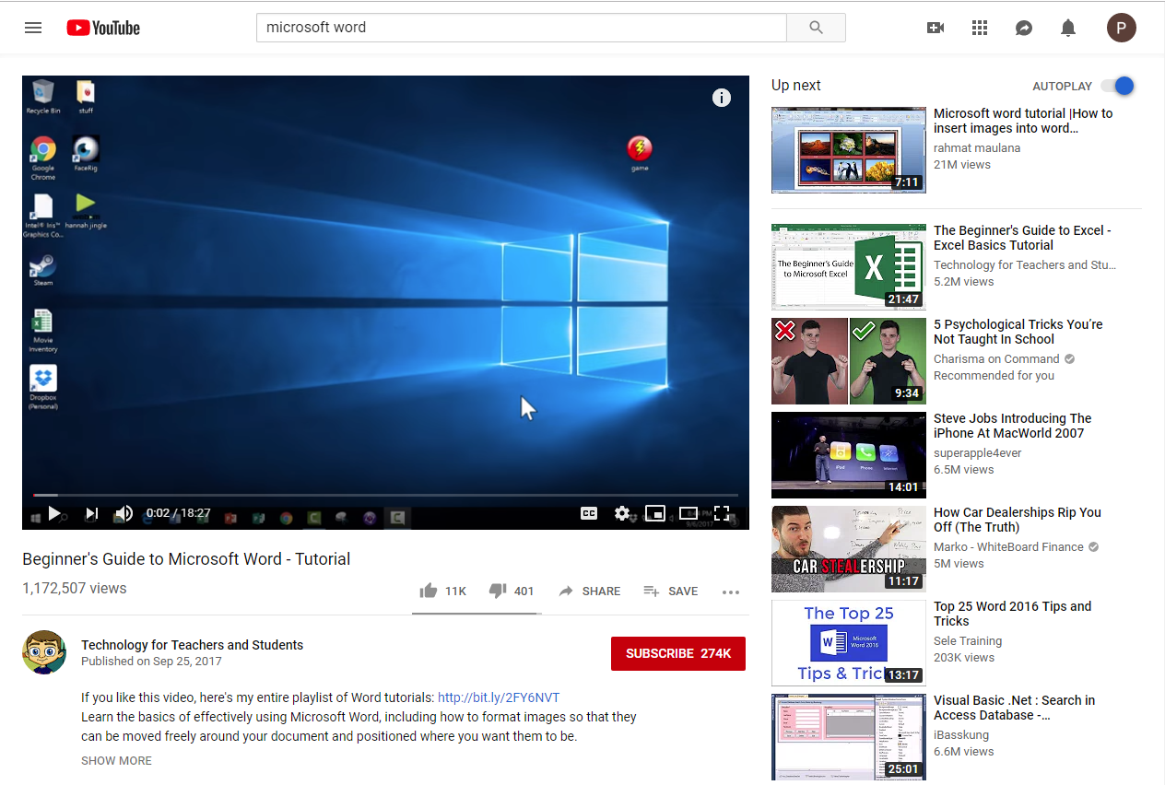
100-0
9
7
6
5
4
3
2
1
- Play/pause the video.
- Volume control.
- The amount of the video you’ve watched and the full video length.
- Turn closed captioning (subtitles) on and off.
- Settings like video speed (as well as another place turn on subtitles and autoplay)
- The three boxes at the end of the player controls will change the size of the video—very small, large, and full screen.
- Video description and the creator’s username. Click on them (in this case, where it says Technology for Teachers and Students) to see more of their videos.
- Your account settings (a Google account is the same as a YouTube account—if you aren’t logged in, this space will look like: When you click it, you will be asked to sign in with your Google account.
- Toggle the blue circle to turn on or off autoplay. When autoplay is active, the video showing at the top right will play automatically after your current video is finished.
- Recommended videos based on your viewing history.

