Microsoft Excel 2016 – Formulas and Functions

A formula starts with an equal sign. Ex: =(D1+D2) or =(2+4)
A formula can use functions. Ex: =AVERAGE(A1:A40)

All Functions are Formulas. Not all Formulas are Functions.
You can identify Functions if you see the reserved-word Function name. In this case, SUM.
You can mix formulas and functions in a cell.

From Excel 2013 All-in-One for Dummies.

Type | Character | Operation | Example
Arithmetic | + (plus sign) | Addition | =A2+B3
 | – (minus sign) | Subtraction or negation | =A3–A2 or –C4
 | * (asterisk) | Multiplication | =A2*B3
 | / | Division | =B3/A2
 | % | Percent (dividing by 100) | =B3%
 | ^ | Exponentiation | =A2^3

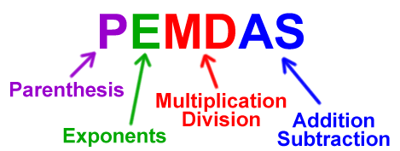

Create first Formulas

Two methods:
- Can do this by typing an equal (=) sign and then the formula in the formula bar.
- Can type the = sign, then click on the first cell, type an arithmetic sign, and then click on the second cell.

Use first Function
Click on an empty cell at the bottom of a row of numbers and enter =SUM(A1:A20)
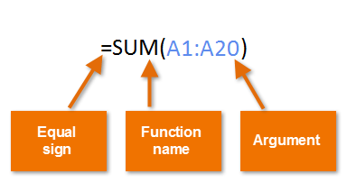
Two methods:
- Can do this by typing the Function in the formula bar, as written above.
- Can type =SUM then click on the first cell, drag the fill handle across or down to the end of range. Release handle, click ENTER.
How do you know if a cell contains Data or a Formula (or Function)?
Click on the cell, if the Formula bar starts with an equal sign, it is a Formula

A function is a built-in operation, such as SUM(), AVERAGE() etc. Functions are always capitalized. Things that go between the parentheses are called the argument(s), and it must be the right type of data, etc. For example, you wouldn’t want to sum a date, you’d want to sum a number.

Three ways (at least) to copy a Formula to another cell
A powerful Excel feature is being able to enter formulas in functions in one row, and quickly duplicate the logic in all of the other rows. For example, set up one salesperson’s commission row the way you want it, and with a few clicks update / populate all the salepeople’s commissions. This process is sometimes called Autofill.

- Enter formula in the first cell, drag the fill handle to new location
- Preselect the entire range for the formula. Enter the formula in the first cell, and press <CNTL Enter> to populate the formula in the entire range.
- Define the range as a Table (advanced topic).

Exercise #3 - on Sheet #2

Use AutoSum
- Click on desired cell.
- Click on Formulas Tab > AutoSum’s drop down arrow to see a list of common functions.
- Click on desired Function.
- Click on range of data for Function, press Enter.
Optional: Select cell with Function, drag fill handle down or across to apply it to other rows or columns.

Exercise #4 - on Sheet #4

Use Insert Function dialog box to search for a Function
- Select a Cell
- Click on Insert Function button on Formulas Tab (far left side).
- Enter a search term, such as “loan repayment” to get a list of possible Functions.
- Click on a function (try PMT) to display Function Arguments dialog box. Move it so it isn’t covering your data.
- The Dialog box will walk you through which data needs to be fed to the PMT Function. Select cell or range of cells to fill in the Values of the arguments, the formula result will appear in the lower left corner of the dialog box.

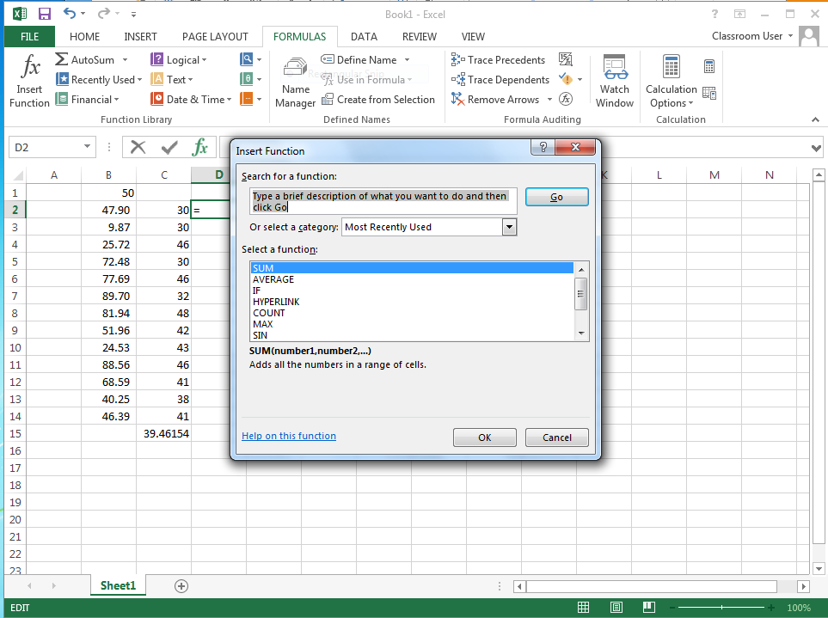 | 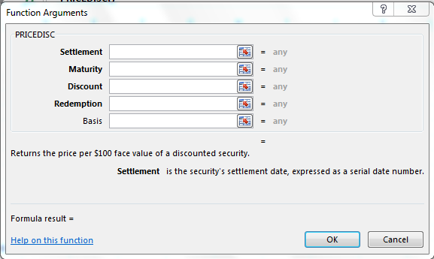

Types of Data
Numbers, Dates / Time, Characters, TRUE/FALSE

Error Messages:

#DIV/0! | The denominator is 0
#NAME? | Range Name doesn’t exist in a worksheet. Check for a typo.
#NULL! | When you enter a space instead of a comma to separate cell references
#NUM! | Wrong type of argument in a function, or a number is too big or small
#REF! | Invalid cell reference, happens with clumsy cut & pasting.
#VALUE! | Wrong type of argument in a function, or if you do math on text
##### | Not really an error message - the column is too narrow to display the field. Adjust column width to display cell.

References
There are 2 kinds of cell references:
- Relative - the default. Copy a formula with the fill handle, and each row’s formula automatically changes the references. Ex: Row A will look like =SUM(A3:A6) and Row C will look like =SUM(C3:C6)
- Absolute - recognized by the $ sign, as in $A$3 or $A2. If you autofill something using an absolute reference, this field’s address will not change.

When editing a formula, use F4 to toggle on the various combinations of Absolute referencing formats. Absolute references are useful to control variables - change just one field to update much data.

Exercise #5 - on Sheet #3

Calculate Salary increase, first using Relative references, and again using Absolute references.
Say we want to increase everyone’s salary by some percentage. Put that percentage in a cell by itself, away from the rest of the data.
Relative reference - in first row, enter =A3*A15. Use Autofill to apply formula to the other rows. FAIL! The A3 and the A15 turn into B3 and B15 in the B row, etc.

Now use Absolute referencing in a formula. =A3*$A$15 Use the <F4> key

Exercise #6 - on Sheet #5

VLOOKUP
- Select columns A:C
- Make a table using Formulas > Name Manager
- Call it ItemLookup
- Use Formulas > Insert Function
- Follow the argument prompts

Stuck? Check out the “Company Info” file, ItemPrices worksheet for the answers.

