MS Office 2013 – Excel Pivot Tables - notes

Introduction
Why You Should Use a Pivot Table
As a rule, what you do in Excel can be split into two categories:
Calculating data
Shaping (formatting) data

Create a Pivot Table

Exercise #1a - create a PivotTable using spreadsheet data
- Open the file “PivotTableData”.
- Click on the “Exercise 1a” tab.
- Select all cells, including header row. (see Figure 1)
- Insert tab > PivotTable button (most left side)
- Click “OK” in the Create PivotTable dialog box. (see Figure 2)
- Automatically directed to new sheet with PivotTable controls. (see Figure 3)
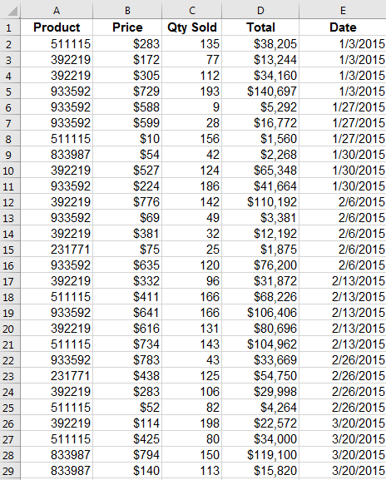  Figure 1- "Sales" tab data | 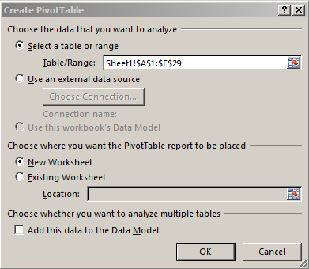  Figure 2- click OK | 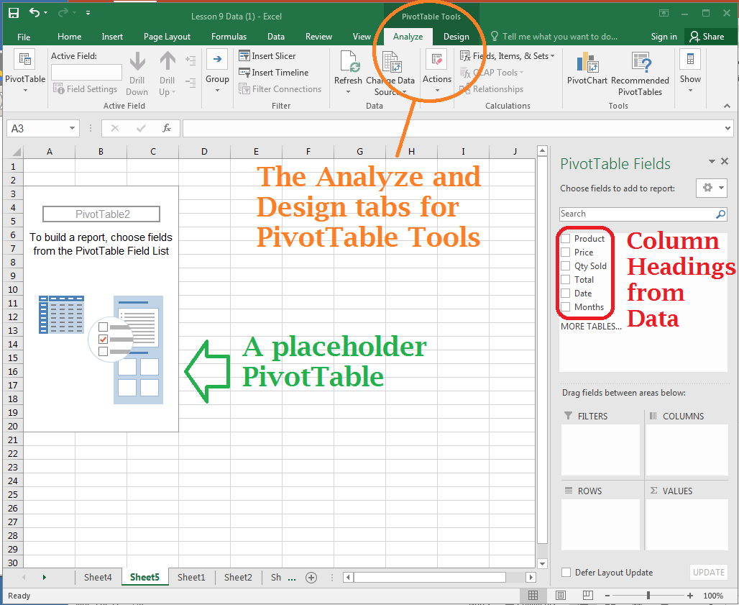  Figure 3 - ready to make a PivotTable!

- Drag and drop fields into Rows, Columns, and Values areas. A good way to start is put “numbers” in the value fields because Excel will Sum, Count, etc. the data. Put text fields in the Rows field, and Dates in the Columns field
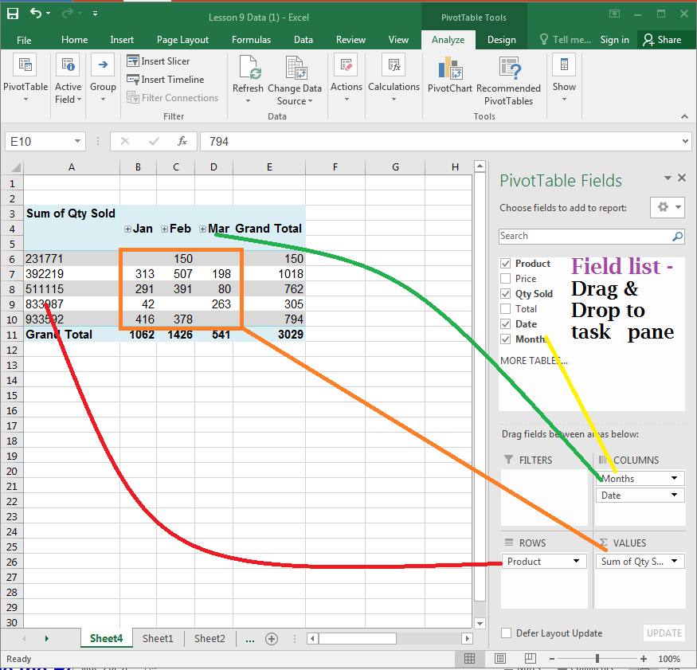

Exercise #1b - create a PivotTable using a Table
- In the same workbook, click on the “Exercise 1b” tab.
- Select all desired cells, including header row. (see Figure 1)
- On the Insert tab, in the Tables group, click the Table button. Click “OK” in the dialog box.
- Notice in the Name box, there is a new thing called Table1.
- On the Insert tab, click on PivotTable, note that now the dialog box is pointing to the new table as the data source.
- Create PivotTable as in Exercise #1a
- Rename PivotTable tabs by

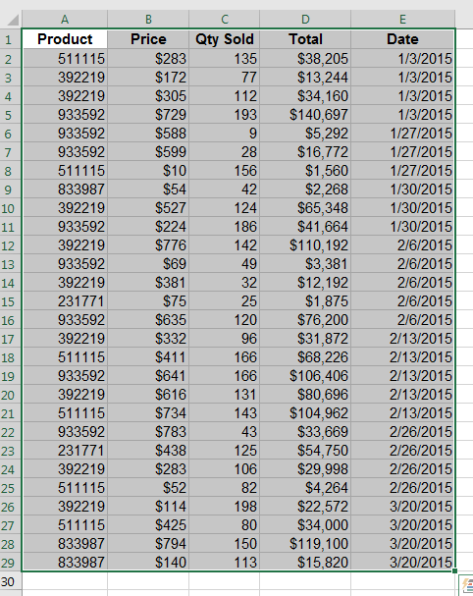 | 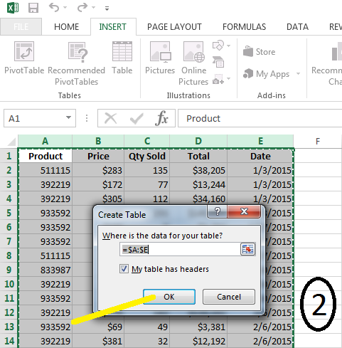 | 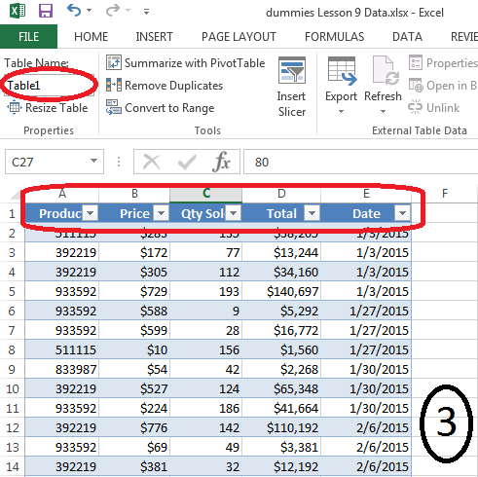 | 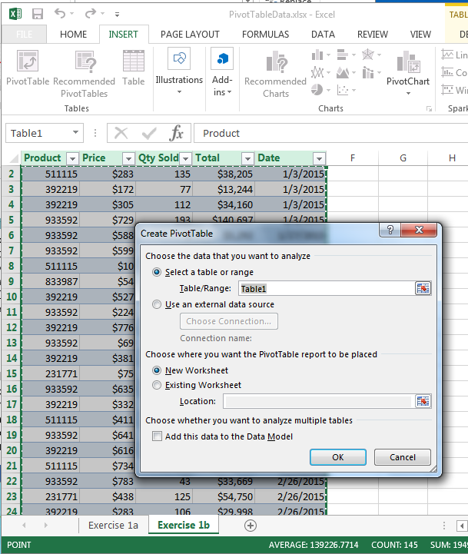

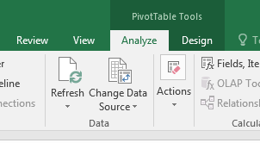

Exercise #1c – differences between the two types of data
- Update a cell(s) of Quantity Sold field in both sets of data.
- Refresh both PivotTables’ caches. (PivotTable Tools > Analyze > Refresh). The PivotTables’ information will update.
- Now add a row to the bottom of each sets of data. (“Exercise 1a” and “Exercise 1b”)
- Refresh both PivotTables’ caches. Notice: the PivotTable created by the Table “sees” a new row and will simply add it into the report. The PivotTable created by selecting data doesn’t “see” it.

Exercise #2a – validate numbers
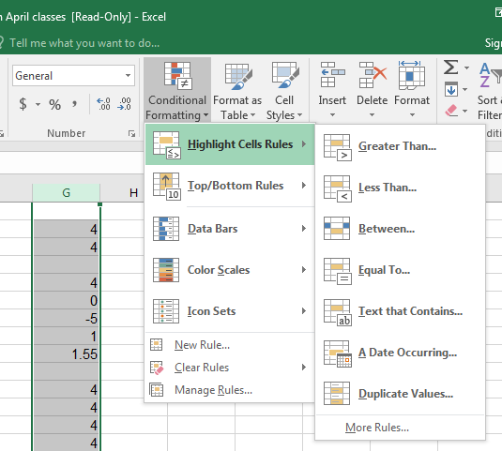
- Using PivotTableData.XLS, click on the Validate tab.
- Look over the data and try to identify the errors. Now we’ll let Excel do the work.
- Select either column C, or cells C2:C19.
- Home > Conditional Formatting > Highlight Cells Rules > Less Than. <click> mouse.
- In the Less Than dialog box, enter a number, like .1, and choose a color that will identify bad numbers. (You can’t sell a negative quantity of something.) Notice that “empty” cells are also identified.

Exercise #2b – make a PivotTable with bad data
- Play around with the Validate tab – create a PivotTable, putting Item in the Rows field, and Qty Sold in the Values field.
- Note that it becomes “Count of Qty Sold”, and it counts how many rows have data.
- Click on the drop down triangle in the Values field. Select Value Field Settings. Change it to Sum.

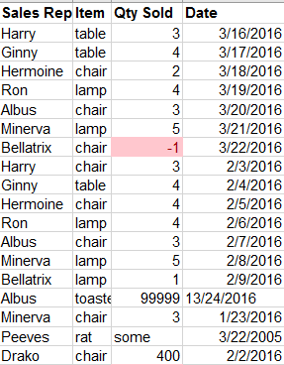  Figure 4 - the bad data. I did a few charts with different data, pressing the “Refresh Data” button after each change. | 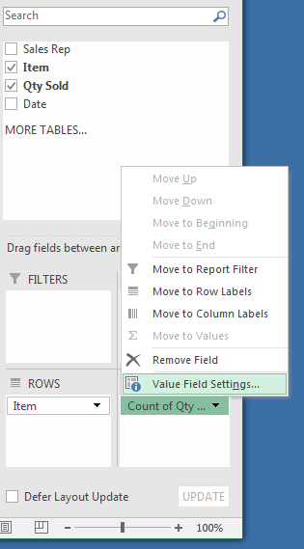  Figure 5 - change to "sum" | 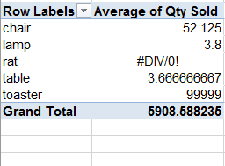  Figure 6 - very unpredictable results.
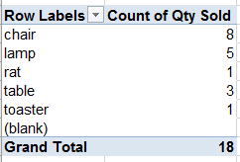
Figure 7 - it counts the number of rows with data

Exercise #3 – different reports from the same data
- Using PivotTableData.XLS, click on the BigData tab.
- By Salesperson, list the item and total that item’s sales
- Who sold the most Media Armoires?
- By region, which products sold the most?
- By date, which salesperson sold the most items?
- What is the biggest seller by dollar amount?
- Which customer uses more than one sales rep?

Format a Pivot Table

Rename tab
- Double-click the working sheet tab for the PivotTable’s sheet.
- Type the new name.
- Press Enter

Adjust the column width
- Select the column(s) that you want to change
- On the Home tab, in the Cells group, click Format
- Under Cell Size, click AutoFit Column Width.
- Tip: to quickly autofit all columns on the worksheet, click the Select All button and then double-click any boundary between two column headings.

Update number formatting
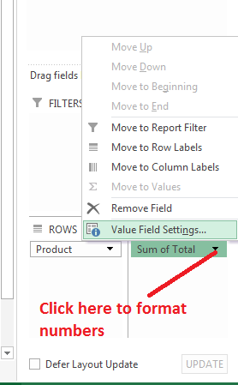
The PivotTable does not pick up formatting from the original data. It is necessary to re-format numbers.
- Click on the down arrow next to the desired field in the Values section of the task pane (Lower right hand corner).
- In the pop-menu, click Value Field settings… to bring up the Value Field Settings menu.
- Click on Number Format (bottom left of pop up).
- Apply formatting as in regular worksheet. Ex: Click on Number, change number of decimals. Or ex: click on Date and format mm/dd/yyyy. Click OK.

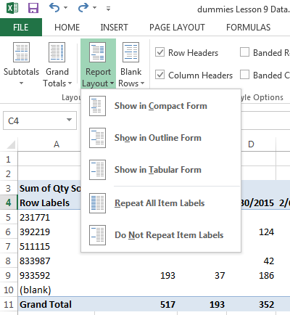

Change report layout choices
PivotTable Tools > Design > Layout > Report Layout
There are three types of reports: Compact, Outline, and Tabular.
Each can be further customized with color by applying a PivotTable Style.

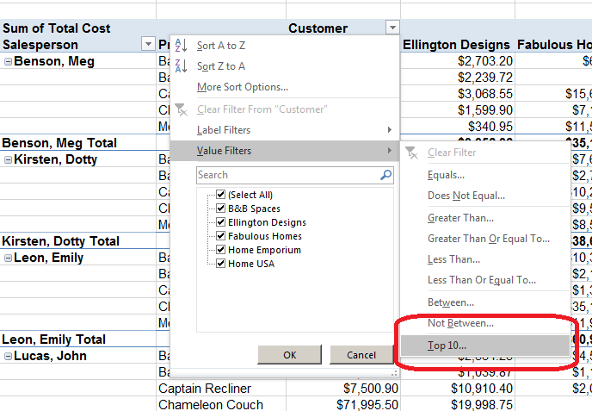
Filters
To filter data, look for the symbol (may be in black & white).
There are a few ways to do this, but the best way is to select the drop down triangle from a Column header. From here, you can sort the data, and filter it by using Values Filters to limit what you see.

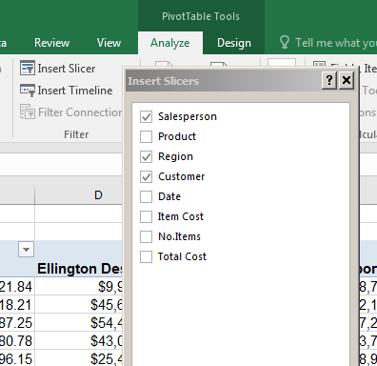

Slicers
A great improvement over just filtering data. Much more interactive.
PivotTable Tools > Analyze > Insert Slicer
Select one or more fields to control data.

Click and Drag slicers so you can see your data.
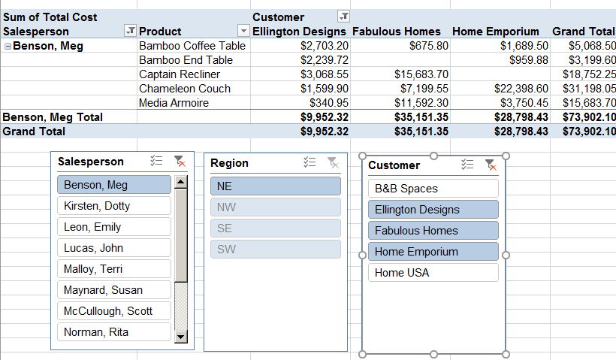
<shift> click to select more than one value.

Miscellaneous
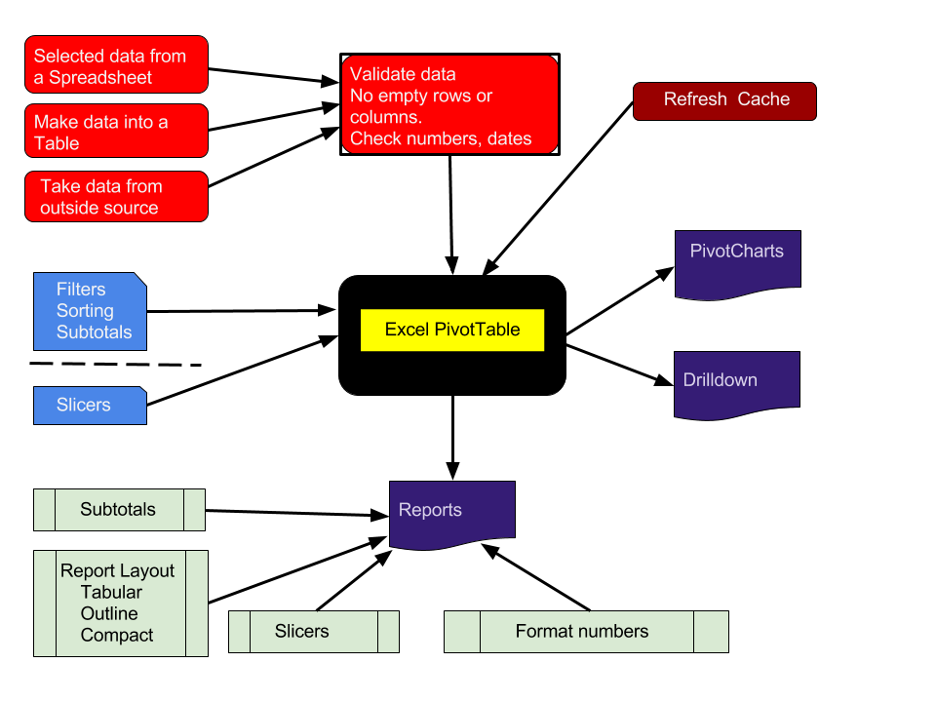
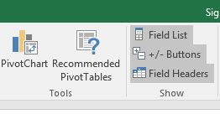
If the PivotTable Pane panel disappears, toggle it back on by PivotTable Tools > Analyze > Show > Field List

